E:\CivicConnect> python -m venv .venv
PS E:\CivicConnect> .\.venv\Scripts\Activate

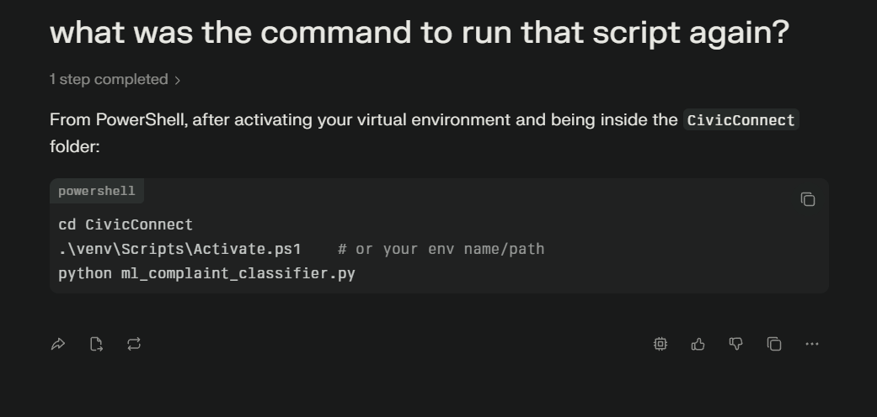

SAMPLE COMPLAINTS:
